Experiment - 1

Operating Systems Lab

Syeda Reeha Quasar

14114802719

4C7

Aim

To write about different types of operating systems and steps to install Linux installation.



# **EXPERIMENT – 1**

## **Aim:**

## To write about different types of operating systems and steps to install Linux installation.

## **Different Operating Systems:**

**1. MS-DOS:**

MS-DOS which is short for Microsoft Disk Operating System is a non-graphical command line operating system developed for IBM compatible computers with x86 microprocessor. The operating system used a command line interface for the user to input commands to navigate, open and manipulate files on their computer.



**Features:**

* It is a single user operating system meaning only one user can operate at a time.
* It is a lightweight operating system allowing users to have direct access to the BIOS and its underlying hardware.
* Loads data and programs from external sources and brings them into the internal memory so they can be used on the computer.
* Enables the computer to perform input and output operations such as taking commands from keyboard, printing information on the screen.
* It is very helpful in file management like creating, editing, deleting files, etc.
* It also controls and manages other external devices such as the printer, keyboard or external hard drive using various drive utilities.

**Drawbacks:**

* It does not allow multiple users to operate on the system.
* It does not support a graphical interface hence the mouse cannot be used to operate it.
* It does not support multiprogramming meaning it can only have one process in the ram.
* It lacked memory protection which meant no security, and less stability.
* It has difficulty in memory access when addressing more than 640 MB of RAM.

**2. Windows Operating System:**

Windows is an operating system designed by Microsoft to be used on a standard x86 Intel and AMD processors. It provides an interface, known as a graphical user interface (GUI) which eliminates the need to memorize commands for the command line by using a mouse to navigate through menus, dialog boxes, buttons, tabs, and icons. The operating system was named windows since the programs are displayed in the shape of a square. This Windows operating system has been designed for both a novice user just using at home as well as for professionals who are into development.



**Features:**

* It is designed to run on any standard x86 Intel and AMD hence most of the hardware vendors make drivers for windows like Dell, HP, etc.
* It supports enhanced performance by utilizing multi-core processors.
* It comes preloaded with many productivity tools which helps to complete all types of everyday tasks on your computer.
* Windows has a very large user base so there is a much larger selection of available software programs, utilities.
* Windows is backward compatible meaning old programs can run on newer versions.
* Hardware is automatically detected eliminating the need of manually installing any device drivers.

**Drawbacks:**

* Windows can be expensive since the OS is a paid license and the majority of its applications are paid products.
* Windows has high computer resource requirements like it should have high ram capacity, a lot of hard drive space and good graphics card.
* Windows slows and hangs up if the user loads up many programs at the same time.
* Windows includes network sharing that can be useful if the user has a network with many PCs.
* Windows is vulnerable to virus attacks since it has a huge user base and users have to update the OS to keep up-to-date with security patches.

**3. LINUX Operating System:**

The Linux OS is an open-source operating system project that is a freely distributed, cross-platform operating system developed based on UNIX. This operating system is developed by Linus Torvalds. The name Linux comes from the Linux kernel. It is basically the system software on a computer that allows apps and users to perform some specific task on the computer. The development of the Linux operating system pioneered open source development and became the symbol of software collaboration.



**Features:**

* Linux is free, can be downloaded from the Internet or redistributed under GNU licenses and has the best community support.
* Linux OS is easily portable which means it can be installed on various types of devices like mobile, tablet computers. It is a multi-user, multitasking operating system.
* BASH is the Linux interpreter program which can be used to execute commands.
* Linux provides multiple levels of file structures i.e. hierarchical structure in which all the files required by the system and those that are created by the user are arranged.
* Linux provides user security using authentication features and also threat detection and solution is very fast because Linux is mainly community driven.

**Drawbacks:**

* There’s no standard edition of Linux hence confusing for users and also becoming familiar with Linux may be a problem for new users.
* More difficult to find applications to support user needs since Linux does not dominate the market.
* Since some applications are developed specifically for Windows and Mac, those might not be compatible with Linux and sometimes users might not have much of a choice to choose between different applications like in Windows or Mac since most apps are developed for operating systems that have a huge user base.
* Some hardware may not be incompatible with Linux since it has patchier support for drivers which may result in malfunction.
* There are plenty of forums to resolve Linux issues, but it may not always match the user’s own level of technical understanding.

**4. Solaris Operating System:**

Solaris or SunOS is the name of the Sun company’s Unix variant operating system that was originally developed for its family of Scalable Processor Architecture-based processors (SPARC) as well as for Intel-based processors. The UNIX workstation market had been largely dominated by this operating system during its time. As the Internet grew Sun’s Solaris systems became the most widely installed servers for Web sites. Oracle purchased Sun and later renamed it to Oracle Solaris.



**Features:**

* Solaris is known for its scalability. It can handle a large workload and still delivers indisputable performance advantages for database, Web, and Java technology-based services.
* Solaris systems were known for their availability meaning that these operating systems hardly crashes at any time and because of its internet networking-oriented design and broad scope of features it makes the job of adding new features or fixing any problems easy.
* It is built for network computing as it provides optimized network stack and support for advanced network computing protocols that delivers high-performance networking to most applications.
* Solaris has advanced, unique security capabilities which includes some of the world’s most advanced security features, such as user rights management, cryptographic Framework and secure by default networking that allows users to safely deliver new solutions.
* Provides tools to enable seamless interoperability, test new software and efficiently consolidate application workloads.

**Drawbacks:**

* Solaris is quite expensive since it’s an enterprise operating system. Also, Solaris doesn’t provide updates for free.
* Solaris lacks good graphical user interface support and is not user friendly.
* Hardware support is not nearly as good as many other operating systems.
* Performance would degrade considerably since Solaris cannot make use of different hardware that efficiently.
* Solaris sometimes becomes unstable and crashes due to total consumption of CPU and memory.

**5. Symbian Operating System:**

Symbian OS was the most widely-used smartphone operating system in the world based on ARM architecture, until it was discontinued in 2014. It was developed by Symbiant Ltd, which was a partnership among PDA devices and smartphone manufacturers like Psion, Motorola, Ericsson, and Nokia. The Symbian Operating System was developed into two sub-systems where the first is the microkernel-based operating system with its associated libraries, and the other being the interface of the OS with which the user interacts. It was explicitly developed for smartphones and hand held digital devices since this operating system consumes very low power, battery-based devices and also for ROM-based systems.

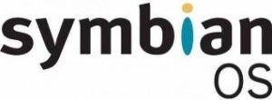

**Features:**

* Its kernel known as EKA2 features preemptive multithreading, scheduling, memory management system and device drivers.
* Allows third party software to enhance the platform for better performance of the operating system.
* Symbian Interface is easy to use and very user friendly.
* Applications for Symbian are normally written in C++ or Symbian C++ using Symbian Software Development Kit (SDK).
* Symbian can also run applications written in Python, Java ME, Flash Lite, Ruby and .NET.
* Connectivity is lot easier and faster.
* Symbian OS has good efficiency and stability.

**Drawbacks:**

* Responsiveness is not smooth and sensitive as other operating systems.
* The Symbian OS is very vulnerable and can be easily affected by a Virus.
* Lack of virtual memory.

**6. Android Mobile Operating System:**

Android is a Google’s Linux based operating system it is designed primarily for touch screen mobile devices such as smartphones and tablet computers. The hardware which can be used to support android is based on three architectures namely ARM, Intel and MIPS design lets users manipulate the mobile devices intuitively, with finger movements that mirror common motions, such as pinching, swiping, and tapping making these applications comfortable for the users.



**Features:**

* The android operating system is an open source operating system that means that it’s free and any one can use it.
* Android offers optimized 2D and 3D graphics, multimedia, GSM connectivity, multi-tasking.
* Android OS is known for its friendly user interface and exceptionally customizable according to the user’s taste.
* Huge choice of applications for its users since Playstore offers over one million apps.
* Software developers who want to create applications for the Android OS can download the Android Software Development Kit(SDK) to easily develop apps for android.
* Android would consume very little power but deliver extreme performance since its hardware is based on ARM architecture.

**Drawbacks:**

* The design and coding of intuitive modern user experiences and interfaces poses a difficulty because of its dependency on Java.
* Most apps tend to run in the background even when closed by the user draining the battery.
* Performance is bound to take a hit as multiple programs run simultaneously in the background at any given time.
* Android phones overheat especially when indulged in hardcore productivity tasks or heavy graphics.
* Apps have lower security profiles and make users more susceptible to data breaches.

**7. iOS Mobile Operating System:**

iOS which is short for iPhone OS is a mobile operating system created and developed by Apple Inc. exclusively for its hardware like A12 Bionic chip that presently powers many of its mobile devices, including the iPhone, iPad, and iPod. The iOS user interface is based upon using multi-touch gestures such as swipe, tap, pinch, and reverse pinch. The purpose of these finger actions is to provide the user with fast responsive inputs given from multiple fingers to the multi-touch capacitive screen display.

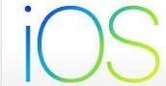

**Features:**

* It is written in C, C++, Objective-C and Swift and is based on the Macintosh OS X.
* Has excellent and intuitive user interface and very fluid response. Performance of iOS is unbeatable.
* iOS comes with a lot of default apps, including an email client, web browser, media player and the phone app.
* Availability of higher quality apps which can be downloaded from the Appstore.
* Apple has provided its own iOS software development kit (SDK) for the developers to create applications for Apple mobile devices.
* iOS is much safer than other mobile operating systems and has fewer security breaches as well.
* Provides regular updates and security patches.

**Drawbacks:**

* The OS is closed source instead of open source hence beta testing taking a lot of time since its only available to limited developers.
* The amount of memory space the iOS applications occupy is very large when compared with other mobile platforms.
* Lack of customization compared to other operating systems. Doesn’t allow third party installations.
* Having intense graphics and animations consumes more power and causes battery drains.
* iOS is a resource intensive operating system due to which older devices struggle to run it.

## Applications and their suitable Operating Systems:

**1. Database and Web Server Management:**

The best suitable operating system for database and web server management is SOLARIS, is Unix Operating system, which itself is designed for enterprise web servers where robust applications and database is deployed where throughput is very high and needs the server 24×7 up and less down time.

* Solaris has Zettabyte File System(ZFS) which is a revolutionary file and logical volume manager that control the storage and retrieval of data which is not found in any other operating system.
* Solaris is provided with a Service Management Facility (SMF) that is responsible for management of system and application services that improves the availability of a system by ensuring that essential system and application services function normally without any troubles even in the case of hardware or software failures which is also known as Oracle Solaris Predictive Self-Healing capability.
* Solaris provides awesome observability utilities which can be used to find performance bugs, functional bugs and kernel bugs.
* Solaris scales well on multi-socket multicore systems with a large number of cores due to Solaris’ broader CPU support but also to the architecture of the OS itself. Solaris can mix and match vertical and horizontal scalability whereas most of the other operating systems only provide vertical scaling.
* Solaris has always provided strict security providing additional barriers and immune systems to prevent any data breaches to their servers.

Hence since Solaris is a reliable, very stable, extremely fast, and secure operating system compared to other OS which have raw performance and security problems it is the ideal operating system for any database management systems like SQL and web service servers.

**2. Cluster Computing:**

Clustering is a technique where multiple computers, storage devices and redundant interconnections are used to create a single highly available system. Each computer in it is a node. The best preferred operating system for cluster computing is LINUX which is a UNIX based open source freely distributed operating system which offers many robust network features.

* Since Linux operating system is highly customizable, which plays an important role in resource management and performance optimization which makes it most convenient for building or setting up large, multi-processor clusters  
  while such modifications are very limited or in some cases restricted in other operating systems like windows.
* Management of storage access is often troublesome when multiple computers are organized to form a cluster, this where Linux’s clustered file system may be come in handy to organize data storage and access across all of the cluster nodes connected.
* Linux clustered file systems will employ utilities to actually power down the faulty node. Linux is scalable hence making it easy to add resources to the cluster.
* Linux has the added advantage of availability of most scientific and engineering software and compilers readily through package managers and they can be easily configured and compiled without hassle.

Since clustering applications are such that they require an OS with utmost portability, performance, scalability and serious computational power, Linux distributions like Redhat or CentOS are best suited for these computer cluster like Beowulf cluster.

**3. Productivity and Daily Tasks:**

The best suitable operating system for productivity is WINDOWS because it is intuitive, cohesive, functional and very user friendly. Windows offers best selection of software and can run on widest variety of hardware that the user has.

* Windows operating systems offer a suite of built-in utilities and applications like text processors, e-mail clients, calendars, calculators, image and video viewers, editors, snapshot tools, voice recorders, and web browsers, and apps for maps, cameras, news, weather, and contacts and many more can be installed from the internet if the user desires.
* Windows provides a suite of productivity applications under Office suite like Word, Presentations, Spreadsheets etc.
* Microsoft’s cloud storage platform OneDrive which helps the users to backup files and use them in any device anywhere. Windows provides a huge range of interface customization options. Touch increases productivity.
* Windows even provides a voice assistant that is capable of tasks like opening apps and web pages, informing the weather, etc. Windows OS makes it easier to arrange windows on the screen and lets users to create multiple virtual desktops for multi-tasking applications.

Hence for creative, productive and daily tasks of users like creating presentations, editing images, surfing the internet, etc Windows is the best operating system.

# **Steps to Install Linux**

Ubuntu is available for both 32-bit and 64-bit systems. Installation below is for 64 bit system.

**Recommended System Requirements for Installation**

* 2 GHz Dual Core Processor
* 10 GB Free Hard disk space
* 2 GB RAM
* Bootable Installation Media (USB/ DVD)
* Internet connectivity (Optional)

**Step:1 Downloaded the ISO file using the following links**

[Download Ubuntu 15.04 (64-bit)](https://www.ubuntu.com/download/desktop)

[Download Ubuntu 15.04 (32-bit)](https://www.ubuntu.com/download/desktop)

**Step:2 Booted system with Bootable USB drive.**

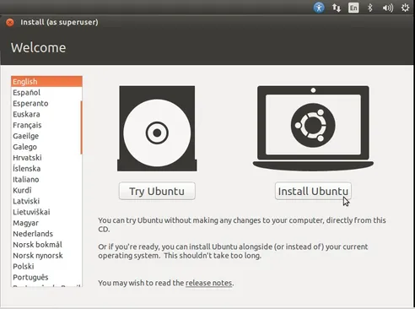

**Step:3 Check Install Prerequisite**

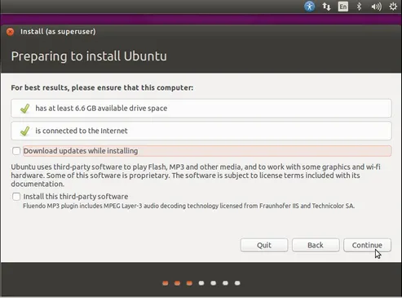

**Step:4 Selected the Installation Type**

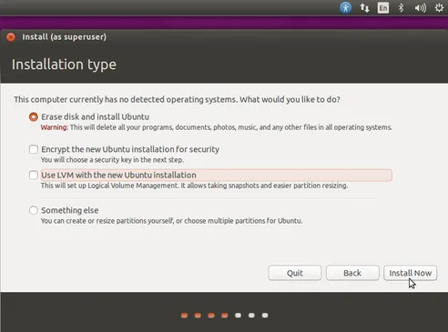

**Confirm to Write Changes to Disk**

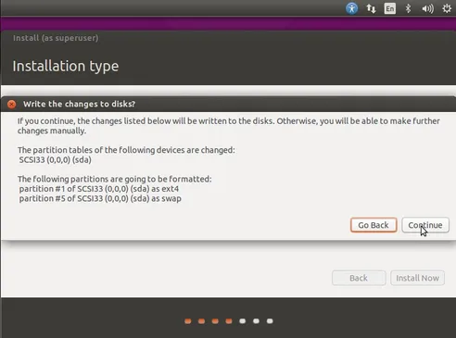

**Step: 5 Select your respective Time Zone**

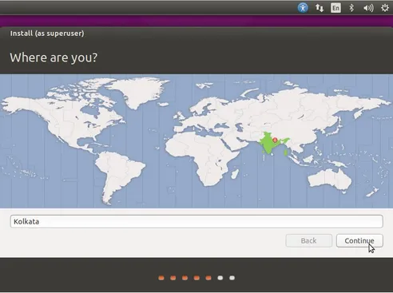

**Step:6 Select your respective Keyboard Layout**

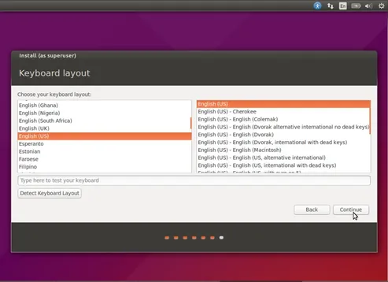

**Step:7 Set the Hostname of your system and User credentials that will be used after installation.**

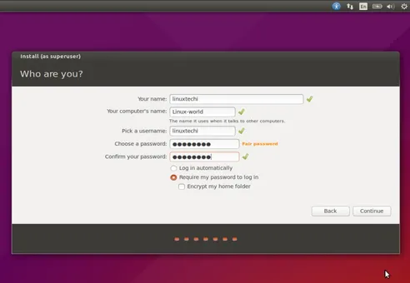

**Step:7 As shown below Installation has started.**

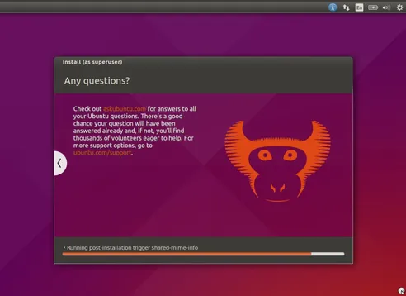

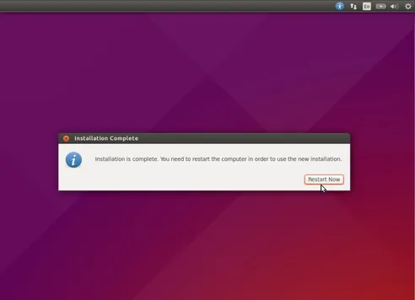

**Step:8 Login Screen after reboot.**

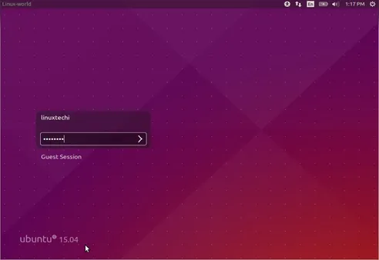

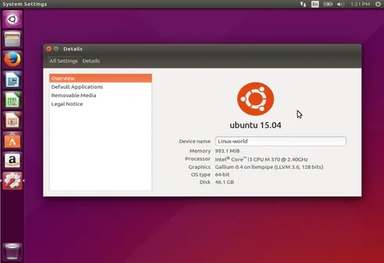

# **Viva Questions**

### **1. What are the different Operating Systems?**

Ans.

### For the most part, the IT industry largely focuses on the top five OSs, including **Apple macOS, Microsoft Windows, Google's Android OS, Linux Operating System, and Apple iOS**.

### **2. What is the difference between windows and linux OS?**

Ans.

The main difference is:

|  |  |  |
| --- | --- | --- |
| **S.NO** | **Linux** | **Windows** |
| **1.** | Linux is a open source operating system. | While windows are the not the open source operating system. |
| **2.** | Linux is free of cost. | While it is costly. |
| **3.** | It’s file name case-sensitive. | While its file name is case-insensitive. |
| **4.** | In Linux, monolithic kernel is used. | While in this, micro kernel is used. |
| **5.** | Linux is more efficient in comparison of windows. | While windows are less efficient. |
| **6.** | There is forward slash is used for Separating the directories. | While there is back slash is used for Separating the directories. |
| **7.** | Linux provides more security than windows. | While it provides less security than Linux. |
| **8.** | Linux is widely used in hacking purpose based systems. | While windows do not provide much efficiency in hacking. |

### **3. What are features of Linux OS?**

Ans.

**1.   Portable Environment**

Linux software operates flawlessly on a variety of hardware platforms. Without the worry of incompatibility, individuals can use Linux operating system on any device. It runs the same way on both high-end and low-end hardware.

**2.   Free and Open-Source**

Its source code is available for anybody to use and alter. Many developers collaborate in organizations to improve and strengthen Linux, and lots of developers constantly work on updating the Linux system.

**3.   Shell/ Command-line Interface**

The Linux system includes essential programs that users can utilize in order to issue commands to the operating system for executing the design flawlessly. You may also direct it to carry out various forms of commands for effectively carrying out the applications.

**4.   End-to-end encryption**

Authentication can help you keep your data protected. Before you may access some critical files, the Linux Operating System requires you to enter a password. Furthermore, the Linux environment allows users to encrypt their data.

**5.   Graphical User Interface (GUI)**

Linux Operating System comes with Graphical User Interface (GUI) abilities in the same way you can with Windows. Similarly, users can install the programs, and the computer graphics will begin to work in the same way that Windows does.

**6.   Configure Keyboards into Different Languages**

Because Linux is available in various languages, it is simple to use it worldwide. As a result, you can change the language on your keyboard as per your preference.

**7.    Frequent New Updates**

Software updates are controlled by the users in Linux. Individuals have the option to pick and choose which updates are required, and there are a plethora of system updates accessible. These upgrades happen considerably more quickly than on other operating systems. Therefore, system upgrades can be deployed without difficulty.

**8.   Lightweight Infrastructure**

Linux is a highly lightweight operating system. Linux has far fewer prerequisites than any other operating system, has a smaller memory footprint, and uses less storage space. Typically, you'll find a Linux Distro with only 128MB of RAM and around the same amount of disc space.

**9.   Extremely Flexible**

Linux is highly flexible, and a variety of desktop applications, embedded systems, and server applications can benefit from the same. It also offers a number of computer-specific limitation settings for admins to allow only essential components to get installed.

